Prepare Multiple Nodes on Alibaba Cloud

1.1. Purchase Single Node on Alibaba Cloud
Step 1: Click https://homenew.console.aliyun.com/home/dashboard/ProductAndService, choose the ECS service,
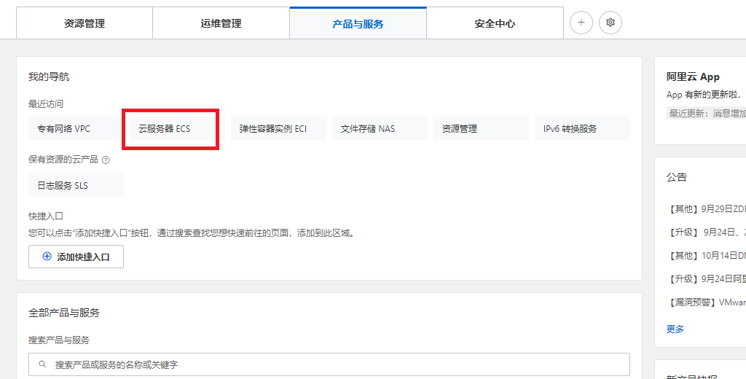
Step 2: Create a new instance, choose pay as you go, choose ecs.c7.2xlarge, choose Ubuntu 16.04 64 bits, choose ESSD, choose no IPv4 address, choose your password Y0urpassword,
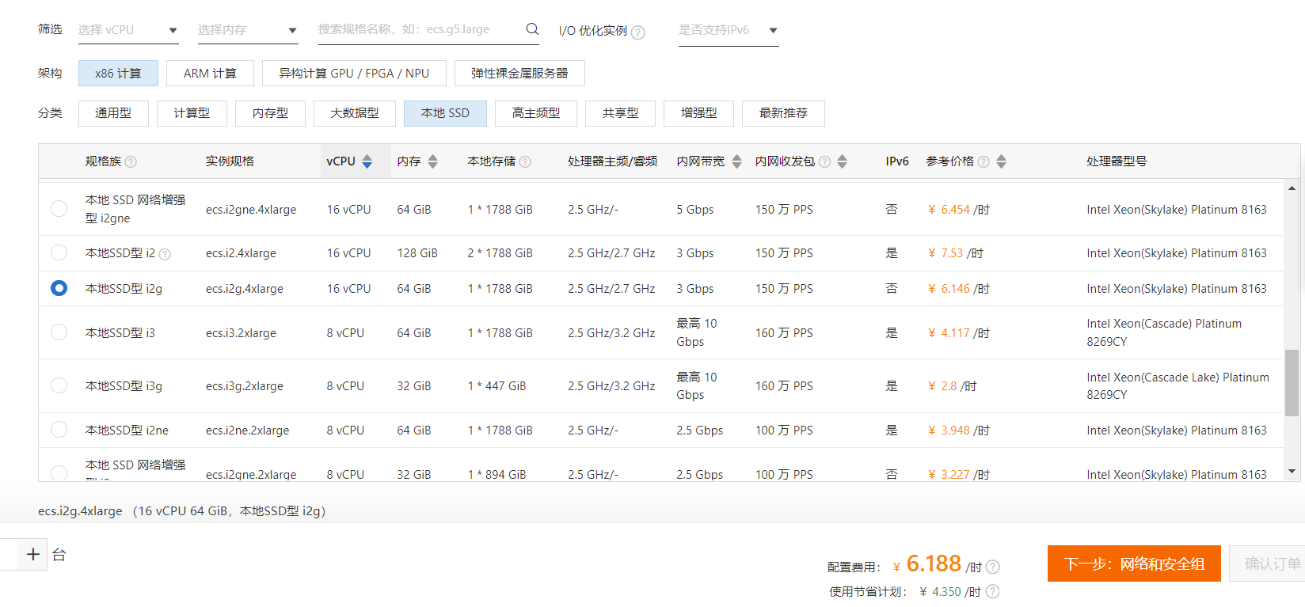
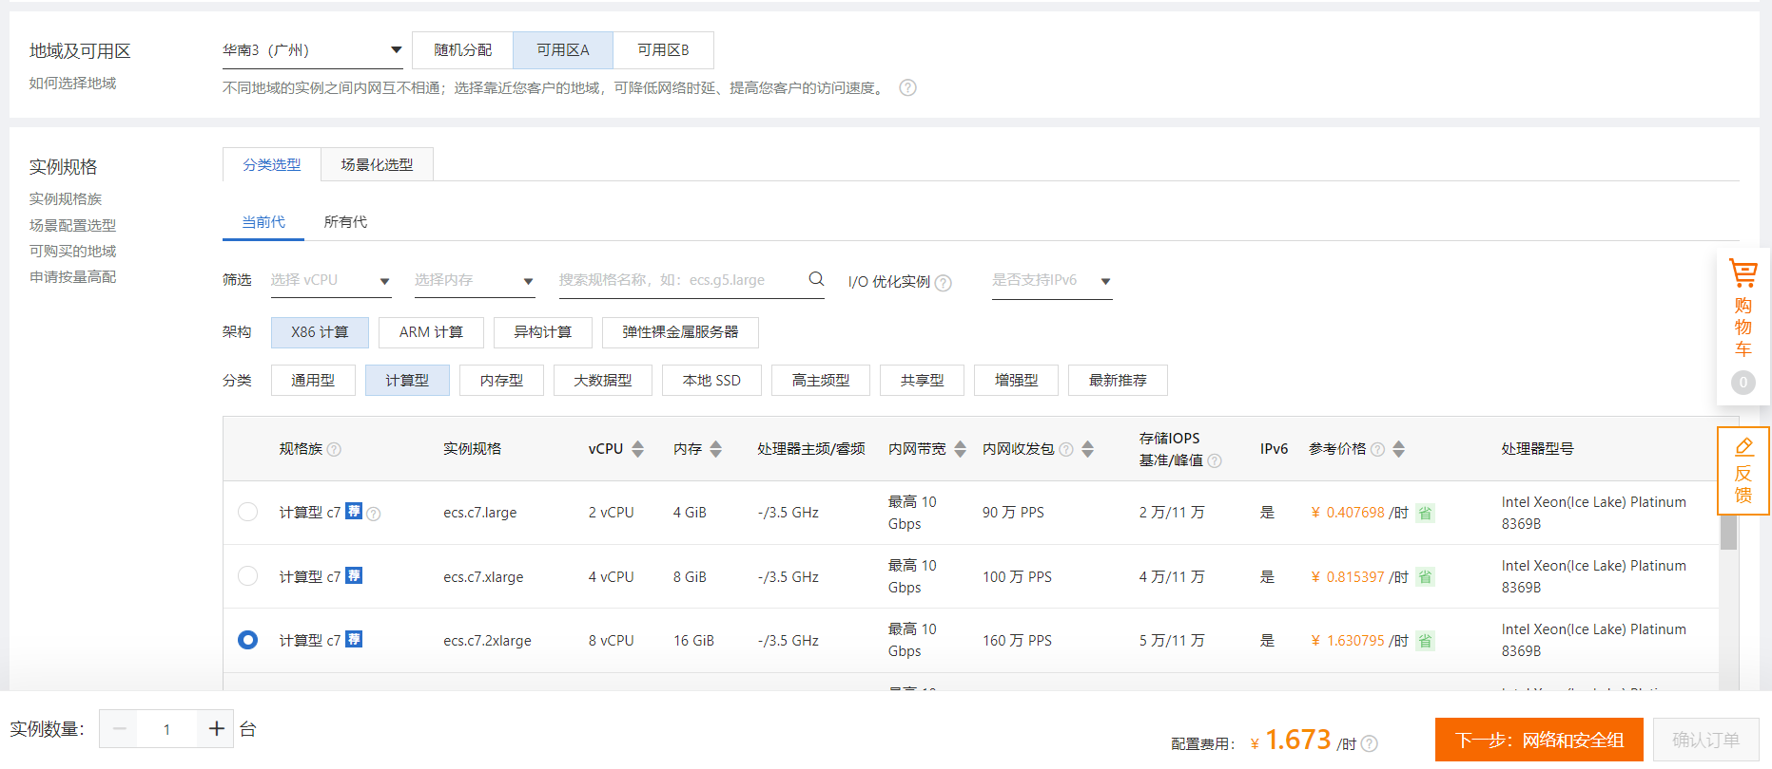
Step 3: Double-check the order,
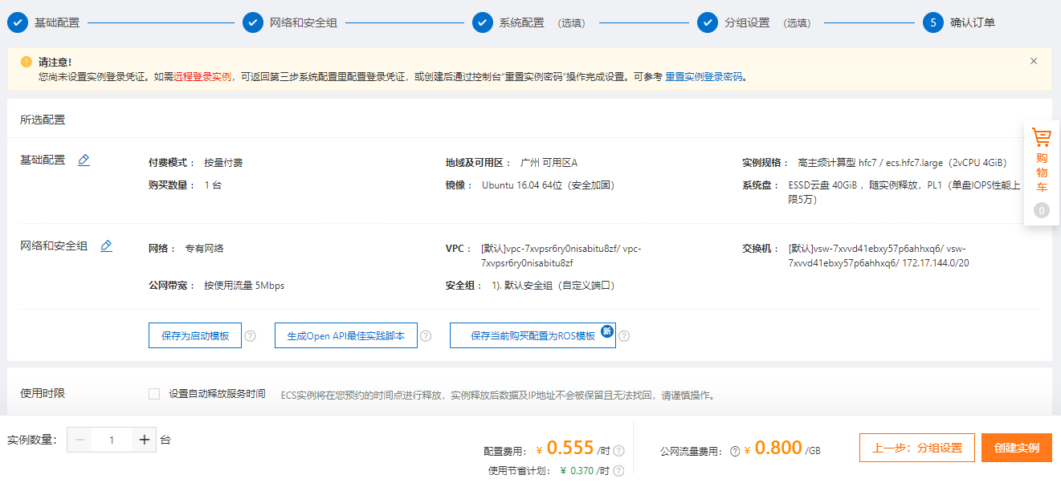

Step 4: Pay the order,
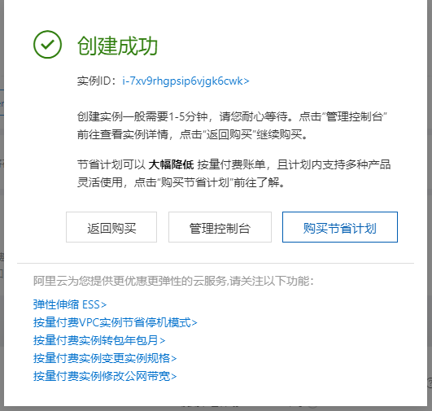
Step 5: Access the ECS instance via Alibaba Workbench, where the default username is root,
So far, the ECS instance cannot access the Internet because it has no IP address.

1.2. Purchase a NAT Gateway

Step 1: Click https://vpc.console.aliyun.com/nat/cn-shenzhen/nats, purchase 2 public IP addresses, create a NAT gateway,
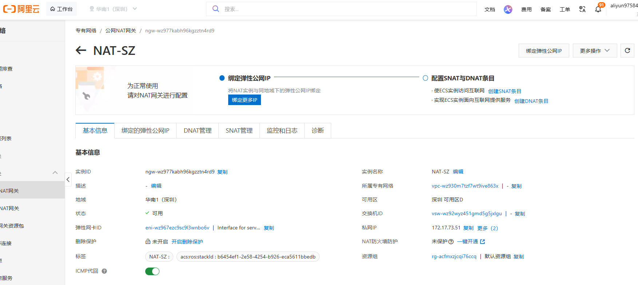
Step 2: After purchasing 2 public IP addresses, we have 39.108.50.174 and 119.23.72.59,
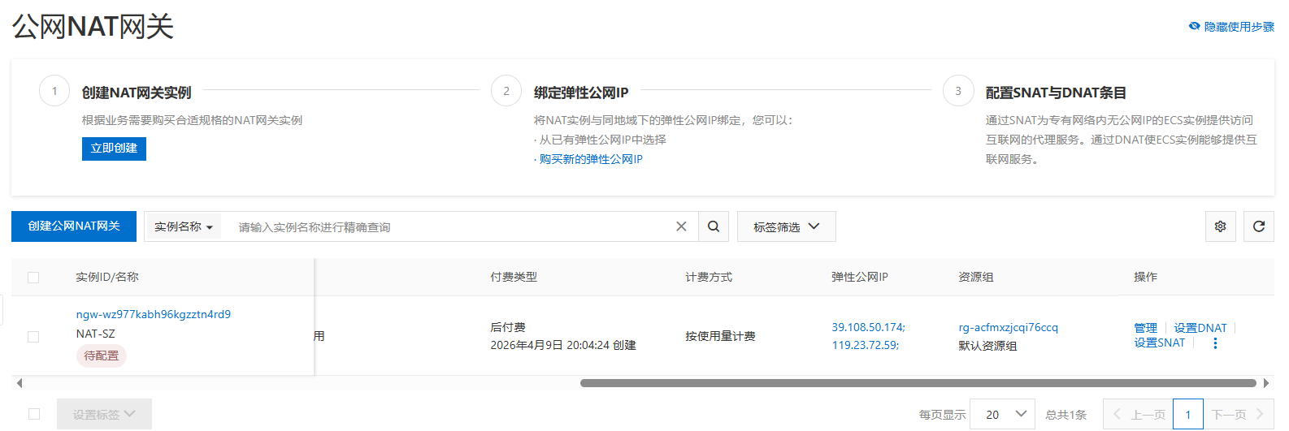

1.3. Purchase Multiple Node on Alibaba Cloud
Step 1: Click https://vpc.console.aliyun.com/vpc/cn-shenzhen/vpcs, purchase another 1 ECS node,
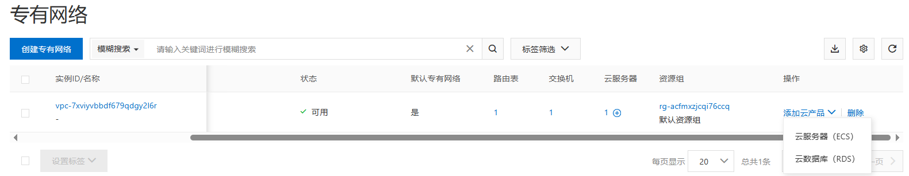
choose pay as you go, choose ecs.c7.2xlarge, choose Ubuntu 16.04 64 bits, choose ESSD, choose no IPv4 address, choose your password Y0urpassword,
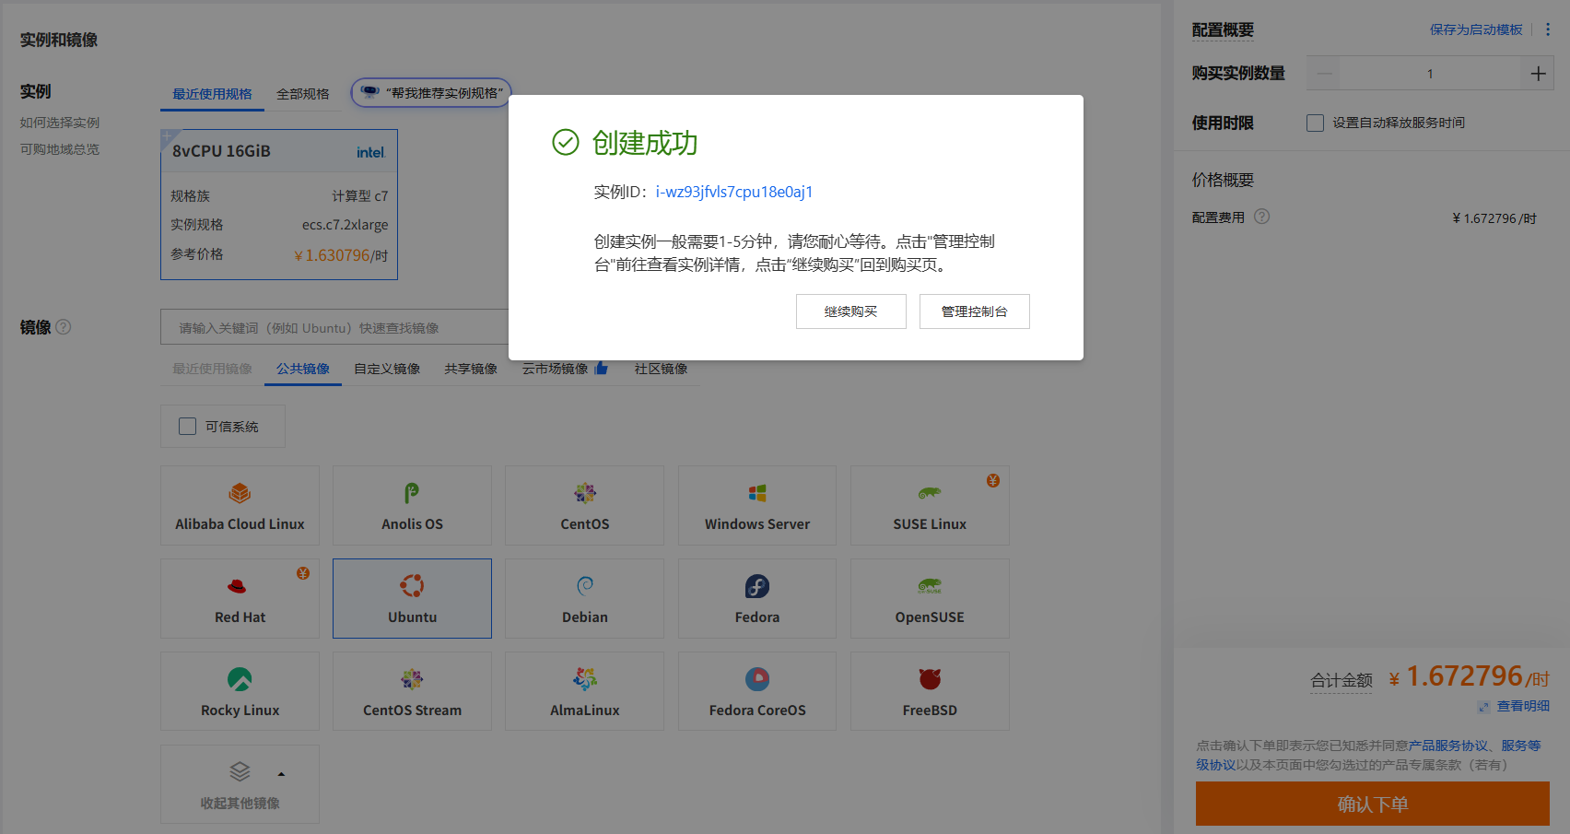

1.4. Configure the NAT Gateway
Step 1: Click https://vpc.console.aliyun.com/nat/cn-shenzhen/nats, configure the NAT gateway, where the IP address 119.23.72.59 for DNAT and 39.108.50.174 for SNAT (DNAT for Internet users and SNAT for VM inside). Currently, we have 1 NAT, 2 Public IP addresses, and 2 ECS, our target is as follows:
For NAT (Public IP):
SNAT | DNAT
39.108.50.174 | 119.23.72.59

For ECS maps (Inside IP):
SNAT | DNAT
- | 172.17.73.50
 | 172.17.73.53

Step 2: Configure the SNAT,
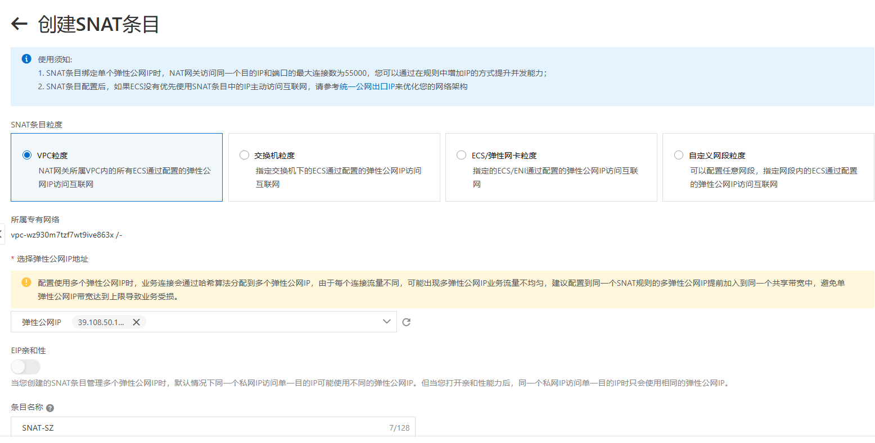

Step 3: Configure the DNAT,
ECS maps:
DNAT Public IP and Port Number | DNAT Inside IP
119.23.72.59:10000 | 172.17.73.50
119.23.72.59:10001 | 172.17.73.53

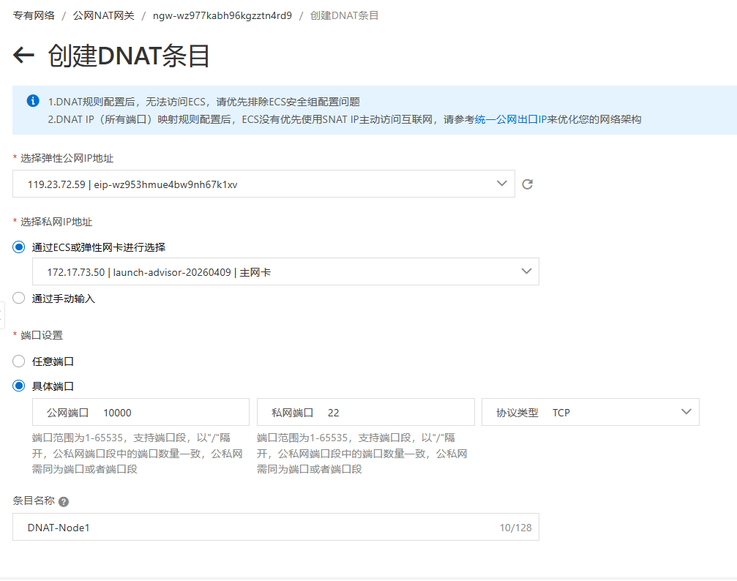
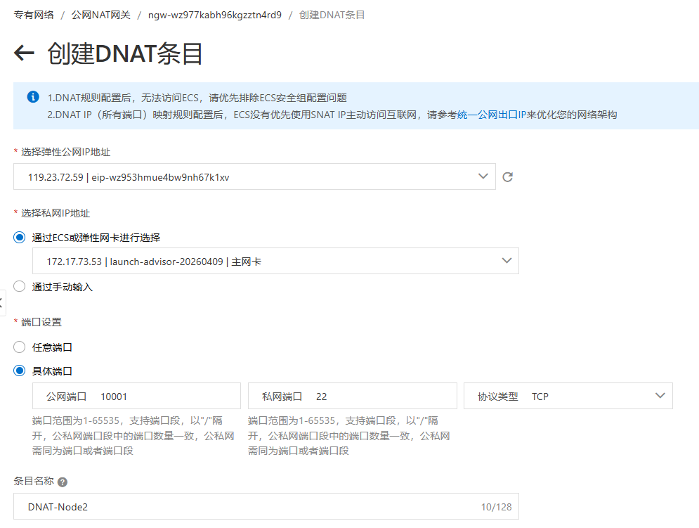
Access the inside IPs via Xshell,
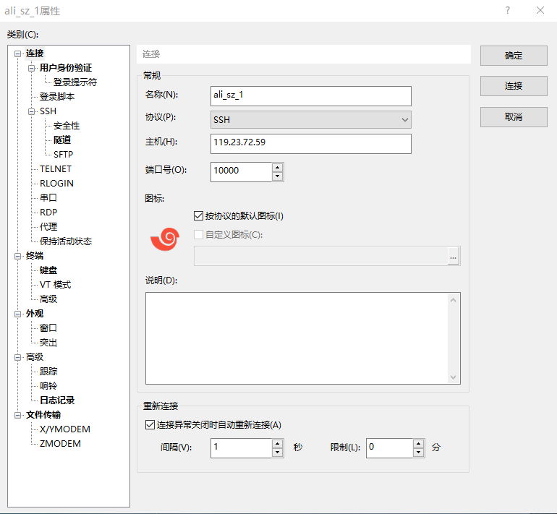
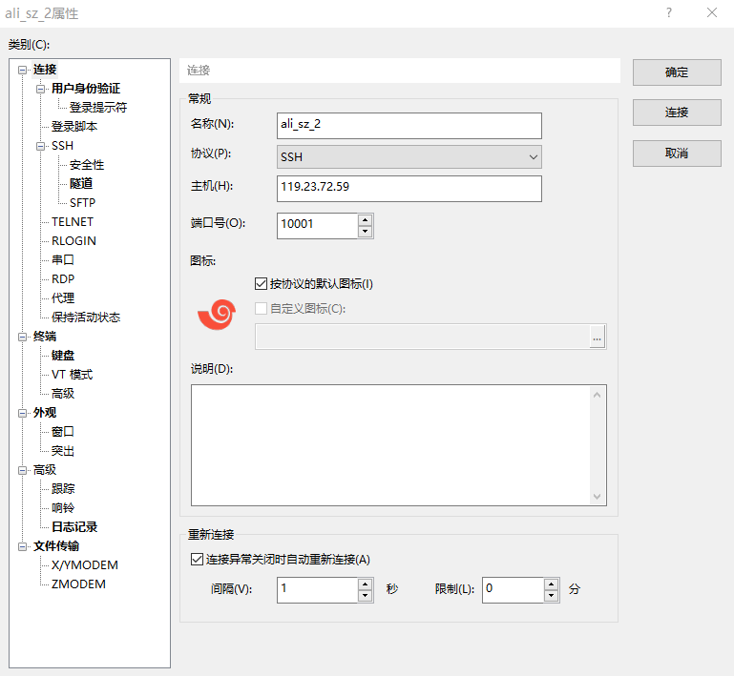

1.5. Configure the password-free SSH
Step 1: The target is as follows,
Host with free-password SSH to
172.17.73.50 | 172.17.73.53

Step 2: Configure the 172.17.73.50,
$ ssh-keygen

$ ssh root@172.17.73.53 'mkdir -p .ssh && cat > .ssh/authorized_keys' < ~/.ssh/id_rsa.pub

$ ssh 172.17.73.53 "echo 'hi'"

1.6. Free the NAT Gateway
Step 1: Click https://vpc.console.aliyun.com/nat/cn-shenzhen/nats/ngw-wz977kabh96kgzztn4rd9/snats, delete SNAT,
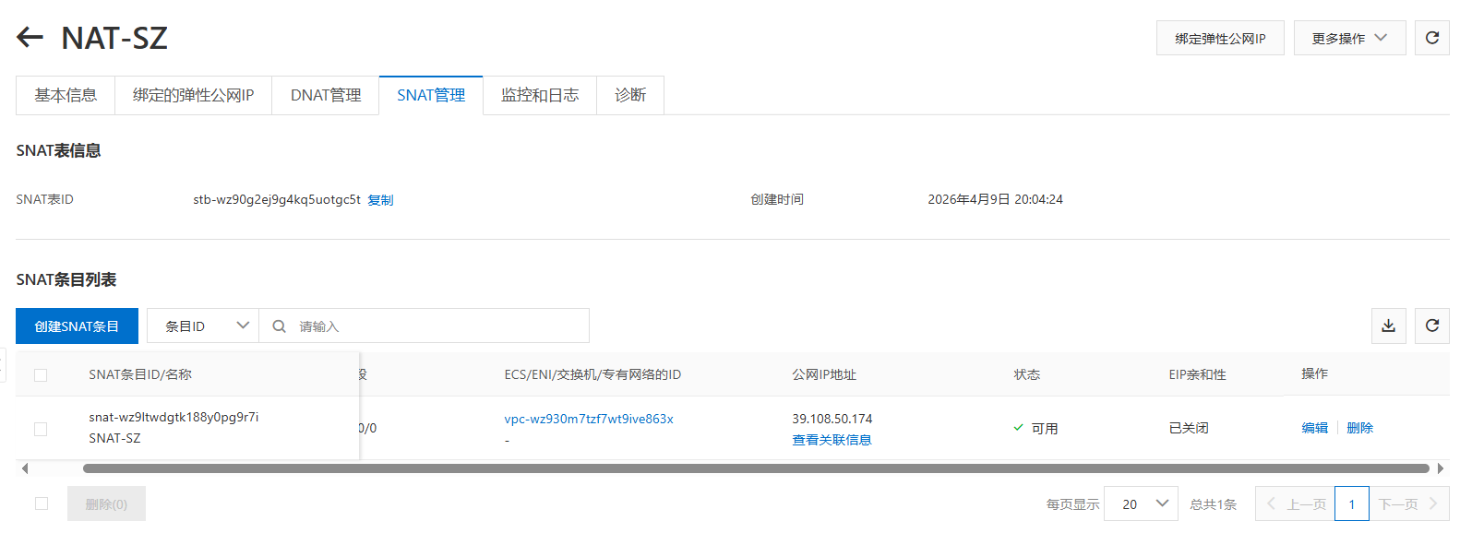
Step 2: Click https://vpc.console.aliyun.com/nat/cn-shenzhen/nats, unbind public IP, free public IP,
Step 3: Click https://homenew.console.aliyun.com/home/dashboard/ProductAndService, delete ECS,
Step 4: Click https://vpc.console.aliyun.com/nat/cn-shenzhen/nats, delete NAT

Prepare Multiple Nodes

2.1. Configure Ms
Step 1: Configure ts
# sudo vi /etc/hosts
:set paste
i

2.2. Instals
Step 1: In node

